Needs Analysis and Time Flow Study to Assess Endoscopic Ear Surgery

30-Mar-2017

REH1510 Thesis Proposal

**Student:** Arushri Swarup 998866071

arushri.swarup@mail.utoronto.ca

**Supervisors:** Dr. Adrian James

adrian.james@sickkids.ca

Dr. Jan Andrysek

jan.andrysek@utoronto.ca

Masters of Applied Science in Biomedical Engineering

Institute for Biomaterials and Biomedical Engineering

Engineering in a Clinical Setting

**Abstract:**

BACKGROUND: Endoscopic ear surgery is a minimally invasive technique to operate inside the middle ear through the ear canal. Though the benefits of reduced length of hospital stay and patient morbidity are valued, ear surgeons have hesitated to adopt the technique. This is because it requires one-handed surgery and existing tools, designed for two-handed traditional invasive microscopic ear surgery, are not optimized for single-handed endoscopic ear surgery.

OBJECTIVE: This study proposes to understand the specific needs, instrument limitations and technologic advancements required to increase adoption of endoscopic ear surgery.

STUDY DESIGN: Part one of this study is to conduct a needs assessment survey, following a two-round Delphi method, where a questionnaire will be sent out to ear surgeons globally. This will aim to identify the current needs and technological limitations that surgeons experience in endoscopic ear surgery. Part two will be a time flow study to record the duration of surgical steps to assess the current limitations of tools and techniques during endoscopic ear surgery. This data will be collated to develop requirements and criteria against which future instrumentation for endoscopic ear surgery can be developed to increase its adoption.

EXPECTED OUTCOMES: As a result of discussions with the primary investigator (an ear surgeon at SickKids hospital) and his colleagues, it is anticipated that the needs assessment survey will show that ear surgeons experience the following difficulties during endoscopic ear surgery: keeping the operative field clean, keeping the endoscope lens clean, cutting bone, single-handed surgery, reaching structures within the middle ear, and gripping structures. The two-round Delphi method will conclude this in a rigorous format, as it is an accepted survey technique in many other areas of surgery. The time flow analysis will identify the inefficiencies during different surgical steps where intervention is required, which may require redesign of existing instruments.

SIGNIFICANCE: These needs and limitations will yield criteria against which instrumentation should be developed. This will be addressing a knowledge gap in the field of endoscopic ear surgery. It will motivate industry and academic researchers to develop better instrumentation and training platforms, increasing the adoption of endoscopic ear surgery.

Add the following as the motor control aspect:

Before, During and after the time flow study for the different types of ear surgeons – traditiaonl, endoscopic and in training, will masure the left and right hand motor cortex EEG signal and brain mapping (look up the technology used to deterimine the size of the region of the brain during muscle activity) to characterize the difference. Since the endoscope is in the left hand, we hypothesize that the right hand, that uses all the tools to manipulate tissue, and perform the surgery will be bigger, with more synaptic connections.

**Introduction:**

Middle ear surgery is traditionally performed through an external incision with visualization of delicate anatomical structures using a microscope. More recently, minimally invasive ear surgical techniques have been developed using endoscopes to access the middle ear through the ear canal without an external incision (1) (2). As with open microscope-guided surgery, this trans-canal endoscopic ear surgery (TEES) technique, allows the surgeon to perform procedures such as ear drum reconstruction, skin growth removal and hearing bone repair (2) (3). The advantages of endoscopic ear surgery are as follows: removing the need for an external incision and reducing postoperative morbidity (4), improving visualization for disease eradication (5) (6), including reducing the rate of residual skin growth (5), and improving hearing by facilitating hearing bone preservation (4) (7).

Despite the enthusiasm of some ear surgeons (otologists), endoscopic ear surgery has not yet been accepted by all practicing otologists (8). The principal challenge with TEES is that a one-handed surgical technique is required as the endoscope is held in the other hand. Ear surgery instruments were developed for two-handed microscope-guided surgery so they are not optimized for the TEES environment (2) (9). As otologists have been trained and gained experience in microscope-guided ear surgery, they have developed techniques with the according instruments and have become accustomed to a two-handed surgical approach. By learning different surgical techniques and gaining experience with the endoscope, most surgeons find that they can complete more cases endoscopically (2) (3) (9). Nevertheless, the learning curve can be steep and frustrating. In the experience of the primary investigator (PI), technological advances in the design of the endoscope, camera, and suction dissection instruments have led to incremental stepwise jumps in this learning curve (10). There is a knowledge gap in the literature where it is not reported exactly why surgeons have not adopted the technique, and what technological and/or training advances would encourage greater adoption. It is proposed that in order to improve the adoption of TEES, the needs of surgeons and current limitations of tools must be determined.

In addition to timing the surgeries, this project will also measure the degree of activity in the motor cortex in the left and right hand regions to understand the neurological changes associated with motor learning of TEES. This will help answer the question of whether new tools would affect the motor learning at the neurological level.

**Background and Literature Review:**

The following describes the use of surveys and time flow analyses in literature to assess: the needs of a field of surgery and the efficiency of a procedure, respectively. These methods will be used to assess the needs of surgeons and current limitations of instruments for TEES. This will attempt to understand how to improve TEES adoption among otologists.

Surveys are widely used to gain information regarding a specific topic by consulting a wide variety of experts in the field. They have been used to assess the challenges of endoscopic neurosurgery in Britain and the current status of endoscopic ear surgery in Canada (9) (11). The Delphi method has been employed internationally in the field of surgery where surveys are sent out to surgeons to form a consensus about varying surgical issues such as: treatment of the retraction pockets of the tympanic membrane, developing a core set of patient-reported outcomes in pancreatic cancer, and an international consensus for sepsis and septic shock definitions (12) (13) (14). A survey, sent to ear surgeons globally, will be conducted to identify the current needs of the TEES technique.

Time flow studies aim to analyze the efficiency of procedures, and have been used for many purposes in surgery, including MRI-guided angioplasty workflow and operating room setup dedicated for minimally invasive laparoscopic surgery (15) (16). This study will assess the feasibility and efficiency of endoscopic ear surgery using the same method.

Talk about the learning to play piano paper and how brain mapping is used to characterize the motor cortex in each hand and what we learned from that paper. How will we apply that to this study.

**Research Question:** Why is transcanal endoscopic ear surgery (TEES) not widely adopted by otologists and what technological advances would encourage more frequent and broader use of TEES? **Hypothesis:** TEES is recognized for its potential and the investigators hypothesize that by conducting a needs analysis survey and a surgical time flow analysis, current limitations of TEES will be explored to develop criteria to improve the adoption of TEES. **Research Objectives:** In order to increase the use of TEES we need to understand: a) the reason surgeons are not adopting TEES by conducting a questionnaire for surgeons and b) limitations of existing tools by conducting time flow analysis.

**Specific Aims and Methods:**

**Part 1: Needs Assessment Survey:**

The aim of the needs assessment survey is to understand the reasons why ear surgeons are not using TEES and what would increase its use. A qualitative assessment of the challenges in TEES caused by limitations in current instrumentation will be completed by performing an online survey of otologists. The Delphi method will be followed to analyze the qualitative results of the survey.

Preliminary interviews with local otologists, who have varied experience in TEES within the University of Toronto, have been conducted to provide a basis of questions to be asked in the survey. They were asked to describe their experience with TEES, the advantages/disadvantages, and possible solutions to difficulties experienced. A pilot survey will be sent to a wider group of otologists to rate the importance of each requirement and will include further open-ended questions for additional comments. Invitations to participate will be sought from the 60 members of the International Working Group on Endoscopic Ear Surgery (IWGEES) plus delegates known to the PI from attendance at ear surgery courses. Results from this pilot questionnaire will be used to generate a formal questionnaire for a global survey of otologists’ opinions. This will attempt to develop a consensus on priorities for improvements in TEES instrumentation.

The pilot survey is included in Appendix C, and requires the participants to rate their need for specific instrument functionalities. The rating scores, a number between 1 and 100, will be analyzed statistically to develop a list of requirements for improvements in instrument design. The survey was developed on RedCap, the SickKids research management software and the scale increments were worded as per research survey guidelines provided by Harvard and the University of Wisconsin (17) (18). Appendix A includes the explanation of the study and survey for the participants.

*Participant Recruitment:* The participants are otologists who will be invited to participate by email. The email addresses will be obtained in two ways: 1) publicly available information, as many ear surgeons list their email on their hospital website. 2) the mailing list of otological societies. Online surveys of surgical practice are frequently distributed by such societies. The following societies of which the PI is a member will be contacted asking for permission to survey their members:

* Canadian Society of Otolaryngology - Head and Neck Surgery
* American Society of Otology
* Politzer Society
* European Academy of Otology and Neurotology
* British Academy of Otolaryngology - Head and Neck Surgery
* International Working Group on Endoscopic Ear Surgery

**Part 2: Time Flow Analysis:**

*Study Design (General Overview):*

The time flow analysis will be recorded by the MASc student during ear surgery. The surgery will be divided into steps, described in Appendix B. The type of instruments used during the different steps and the number of changes between instruments will also be noted. These observations will lead to an appreciation of the ergonomic requirements of the instruments and the design advantages of each for specific maneuvers. The time taken for five surgeons to perform ten surgeries each will be recorded. Each step for each surgeon will have a mean and standard error time, and statistical difference between surgeons for each step will be calculated. This will aim to determine the inefficiencies and address the steps where further instrument design would be beneficial. This would also provide a good benchmark against which to measure efficiency and feasibility of developing future tools. The last half of surgeries will be done using the new tools developed for improving TEES. The results will be compared statistically.

*Participants*: The time flow study will include two kinds of participants: patients, who will be undergoing ear surgery, and surgeons, who will be performing the ear surgery.

*Participant Recruitment*: There will be three experienced TEES surgeons, three experienced traditional microscopic ear surgeons and three resident surgeons who are training in TEES and traditional ear surgery. This will characterize the difference between experienced and in training surgeons.

*Inclusion criteria*: Patient participants: 40 surgical patients, who require cholesteatoma surgery or tympanoplasty (surgical repair of perforated ear drum). Surgeon participants: 5 surgeons with more than one year of experience in endoscopic ear surgery.

*Exclusion criteria:* Residents and fellows who are in training. It would be inappropriate to include surgeons in training in the study as their lack of experience will contribute to delays and lack of efficiency in time flow, confounding the estimate of the contribution of instrument design to surgical time flow. Although the ability of trainees to use different instruments in TEES and the impact of their level of experience on this ability would be of interest, they are beyond the current scope and design of this study.

*Study intervention*: Each surgeon will be observed and recorded performing ten operations. The time and number of instruments changed will be recorded for the steps outlined in the Data Collection Form, included in Appendix B. As well, the EEG and brain mapping technology will be hooked up to the surgeon immediately following surgery. It would be very risky to impede the mobility of a surgeon during surgery as it would pose a heavy risk on the patient and their wellbeing therefore, any brain activity measurements will have to be done after the surgery. (look up the piano paper and figure out what their method was)

*Outcome measures*: The following outcomes will be measured: duration of the surgical steps described above and the number of times the surgeon changes the tool he/she is using during the step.

EEG and brain mapping technology will be used to measure brain region size and activity before and after learning TEES.

*Statistical analysis*: The factor to be studied is the type of instruments used for each surgical step. The block is the surgeon. The response is the time required for the surgical step. Therefore, an ANOVA will be used to determine if there is a statistical difference in the time to complete a surgical step depending on the instruments used.

**Expected Outcomes:**

As a result of the PI’s personal experience and communication with his colleagues and ear surgeons who attended an Endoscopic Ear Surgery skills course in October, 2016, it is anticipated that the following difficulties will be revealed in the needs analysis survey: clearing blood from the operating field, keeping the endoscope lens clean, dissecting, gripping structures, accessing structures that are visible with the endoscope’s wide viewing angle, bone removal beyond certain anatomy, and difficulty with ear drum graft positioning. As well it is anticipated that understanding the needs for TEES and identifying the inefficiencies during surgery would provide a basis of what type of instrumentation should be optimized to improve its adoption. Surgeons previously contacted for the survey will be sent copies of the findings and invited to offer suggestions for improvements in instrument design. It is anticipated that the response rate to this request may be low as surgeons may be protective of their own ideas, but may still help to generate some innovative solutions.

This methodology will collect insight from a variety of surgeons to understand the spectrum of their opinions on TEES and how and/or if it can be improved. Although a potential limitation would be a low survey response rate, the creation of practical and innovative solutions to the challenges of endoscopic surgery is not dependent upon a high survey response rate due to the experience of the PI. Having taught at multiple surgical courses, participated in seminars, attended endoscopic conferences around the world, and by associating with other leaders in the field, the PI has considerable insight into the current status of activity and opinions within the field of endoscopic ear surgery.

See Appendix D for timeline and dissemination plan.

As per the piano paper, I expect that the motor cortex activity of the experienced TEES surgeon will not change as they have already gone through the motor learning process for TEES. I expect that the experienced traditional and resident surgeons will have significant changes in their right hand motor cortext as a result of the motor learning throughout the study.

**Significance and Conclusions:**

Therefore, it is anticipated that conducting a needs analysis survey and a surgical time flow analysis, current limitations of TEES will lead to the development of instruments with the functionalities identified in the results of the survey. It is anticipated that new TEES instruments will increase the range of ear procedures that can be completed minimally invasively and increase the speed and effectiveness of surgery, thereby aiming to improve its adoption among otologists. The design techniques and instruments created will also be applicable to other minimally invasive surgery in bony cavities such as sinus, nasal, spinal and arthroscopic surgery (19), (20), (21). It is envisaged that ultimately, virtual patient models could be used with rapid prototyping and fabrication to create patient specific specialist instruments extending the limits of minimally invasive surgery even further.

**References:**

1. Carlos C, Parkes W, James AL. Application of 3-dimensional Modeling to Plan Totally Endoscopic Per-Meatal Drainage of Petrous Apex Cholesterol Granuloma. 2015;3–4.

2. James AL. Endoscopic middle ear surgery in children. Otolaryngol Clin North Am [Internet]. 2013 Apr [cited 2015 Sep 12];46(2):233–44. Available from: http://www.ncbi.nlm.nih.gov/pubmed/23566909

3. Cohen MS, Landegger LD, Kozin ED, Lee DJ. Pediatric endoscopic ear surgery in clinical practice: Lessons learned and early outcomes. Laryngoscope [Internet]. 2015;n/a – n/a. Available from: http://doi.wiley.com/10.1002/lary.25410

4. Tarabichi M. Endoscopic management of limited attic cholesteatoma. Laryngoscope. 2004;114(7):1157–62.

5. James ÃAL, Cushing ÃS, Papsin ÃBC. Residual Cholesteatoma After Endoscope-guided Surgery in Children. 2015;196–201.

6. Hanna BM, Kivekäs I, Wu YH, Guo LJ, Lin H, Guidi J, et al. Minimally invasive functional approach for cholesteatoma surgery. Laryngoscope. 2014;124(10):2386–92.

7. Obholzer R, Ahmed J, Warburton F, Wareing MJ. Hearing and ossicular chain preservation in cholesteatoma surgery. J Laryngol Otol. 2011;125(2):147–52.

8. Prasad SC, Giannuzzi A, Nahleh EA, Donato G De, Russo A, Sanna M. Is endoscopic ear surgery an alternative to the modified Bondy technique for limited epitympanic cholesteatoma? Eur Arch Oto-Rhino-Laryngology [Internet]. Springer Berlin Heidelberg; 2016;273(9):2533–40. Available from: "http://dx.doi.org/10.1007/s00405-015-3883-3

9. Yong M, Mijovic T, Lea J. Endoscopic ear surgery in Canada : a cross-sectional study. J Otolaryngol - Head Neck Surg [Internet]. Journal of Otolaryngology - Head & Neck Surgery; 2016;1–8. Available from: http://dx.doi.org/10.1186/s40463-016-0117-7

10. Badr-el-dine M, Marchioni D, Presutti L, Flávio J. I n s t r u m e n t a t i o n a n d Tec h n o l o g i e s in E ndos c o p i c Ear Su r ge ry. 2013;46:6665.

11. Marcus HJ, Cundy TP, Hughes-hallett A, Yang Z, Darzi A, Nandi D, et al. Europe PMC Funders Group Endoscopic and Keyhole Endoscope-assisted Neurosurgical Approaches : A Qualitative Survey on Technical Challenges and Technological Solutions. 2015;28(5):606–10.

12. Gerritsen A, Jacobs M, Henselmans I, van Hattum J, Efficace F, Creemers G-J, et al. Developing a core set of patient-reported outcomes in pancreatic cancer: A Delphi survey. Eur J Cancer [Internet]. 2016 Apr [cited 2016 Oct 5];57:68–77. Available from: http://www.ncbi.nlm.nih.gov/pubmed/26886181

13. Kosyakov SY, Minavnina Y V, Pchelenok E V. [The consensus view of the treatment of the retraction pockets of the tympanic membrane]. Vestn Otorinolaringol [Internet]. 2016 [cited 2016 Oct 5];81(1):78–83. Available from: http://www.ncbi.nlm.nih.gov/pubmed/26977575

14. Singer M, Deutschman CS, Seymour CW, Shankar-Hari M, Annane D, Bauer M, et al. The Third International Consensus Definitions for Sepsis and Septic Shock (Sepsis-3). JAMA [Internet]. 2016 Feb 23 [cited 2016 Oct 5];315(8):801–10. Available from: http://www.ncbi.nlm.nih.gov/pubmed/26903338

15. Rube MA, Fernandez-gutierrez F, Cox BF, Holbrook B, Houston JG, White RD, et al. HHS Public Access. 2015;10(5):637–50.

16. Hsiao KC, Machaidze Z, Pattaras JG. Time Management in the Operating Room : An Analysis of the Dedicated Minimally Invasive Surgery Suite. 2004;300–3.

17. Harrison C. Program on Survey Research. Harvad Univ Progr Surv Res. 2007;

18. Taylor-Powell E. Wording for rating scales. Board Regents Univ Wisconsin Syst doing Bus as Div Coop Ext Univ Wisconsin-Extension. 2009;(c):2008–9.

19. Benefits of Minimally Invasive Surgery | AIMIS [Internet]. [cited 2015 Nov 14]. Available from: http://www.aimis.org/benefits-of-minimally-invasive-surgery/

20. AANS - Minimally Invasive Spine Surgery MIS [Internet]. [cited 2015 Nov 17]. Available from: http://www.aans.org/patient information/conditions and treatments/minimally invasive spine surgery mis.aspx

21. Endoscopic Nasal & Sinus Surgery [Internet]. [cited 2015 Nov 17]. Available from: http://care.american-rhinologic.org/ess

**Appendix A: Needs Assessment Survey**

*This appendix outlines the details of the survey. V-1 27-Oct-2016*

The email and landing page of the survey describe the survey to the otologists who will be asked to fill it out. Implied consent is requested so the survey results remain anonymous. The figure below is of an invitation to participate in a survey sent to the PI. The language used is a guide used to describe our survey.

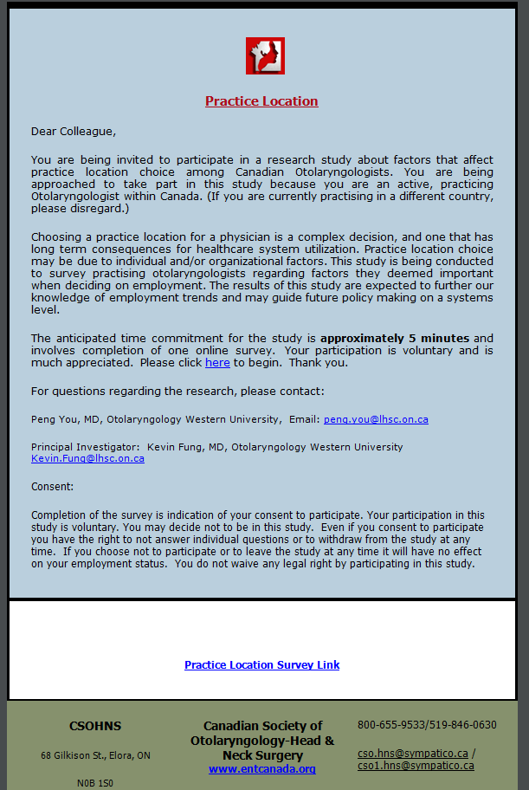

*Email:*

The email will contain the following email script:

“Dear Colleague,

You are being invited to participate in a research study to understand how to increase the adoption of totally endoscopic ear surgery. We would like to invite you to participate in this voluntary, anonymous online survey, because you are a practicing Otolaryngologist. This voluntary survey’s objective is to collect data to answer these research questions by surveying practicing otologists, and to publish the results in a research journal to fill this knowledge gap.

The approximate time to complete the survey is 5 minutes. Your participation or nonparticipation in this survey will be unknown and will not affect your professional status and/or integrity in any way. The survey is to aid in the research of understanding the current experience of endoscopic ear surgery and why it is not widely adopted. This study will be conducted using the two-round Delphi method. The responses of this survey will be collated to develop a second round of more specific questions, which will be sent out in another survey.

For questions regarding the research, please contact:

Arushri Swarup, MASc. Candidate, Institute for Biomaterials and Biomedical Engineering, University of Toronto, email: arushri.swarup@sickkids.ca

Principal Investigator: Dr. Adrian James, Paediatric Otorhinolaryngologist, SickKids Hospital, adrian.james@sickkids.ca

Consent:

By completing and submitting the survey, it will be implied that you consent to participating in the study. Your participation in this study is voluntary, anonymous and confidential. You may decide not to be in this study. Even if you consent to participate you have the right to not answer individual questions or to withdraw from the study at any time.

The survey is available by clicking on the link below:

<Link to survey>”

Landing Page of Survey:

“There is growing interest amongst otologists worldwide around the use of endoscopes in ear surgery. As most ear surgery instruments were developed for use with the microscope, it is possible that changes in instrument design for use with endoscopes may allow more procedures to be completed effectively with a totally endoscopic approach. This project is a not for profit initiative to stimulate the development of instrumentation optimized for endoscopic ear surgery. This survey aims to investigate the suitability of currently available instruments for use in endoscopic ear surgery and identify priorities for improvements in instrument design.

The approximate time to complete the survey is **5 minutes**. The survey will be conducted via a two-round Delphi method. The responses of this survey will be collated to develop a second round of more specific questions, which will be sent out in another survey. The results will then be analyzed and presented in a paper in an otology research journal.

By completing and submitting the survey, it will be implied that you consent to the researchers analyzing and presenting it. You may decide not to be in this study, and may withdraw at any time before submitting the survey.

This survey is completely **voluntary** and will remain confidential and **anonymous** to the researchers. This survey is purely for research purposes.

We thank you for your time. Please continue to begin.”

*Questionnaire:* Please refer to the questionnaire (Appendix C).

In the case that we do not receive any responses within two weeks, we will send out one follow-up email to the invited participants. The email will read:

“Dear Dr.__________,

This is a friendly follow up email to the request to participate in the voluntary survey, linked below, to gather information about why totally endoscopic ear surgery is not widely adopted and practiced. This will aid in a research study aiming to understand the answers to these questions.

It is important to note that this survey is completely voluntary and will remain confidential and anonymous to the researchers. There will be no way to identify the participant to their answers to the survey. As well, participation or nonparticipation in this survey will not affect your professional integrity in any way. This survey is purely for research purposes.

By answering the questions in the survey and submitting it, it will be implied that you consent to filling out your survey and the researchers using the anonymous data to analyze and present it.

We thank you for your time. Please click below to begin.”

<Link to survey>

**Appendix B: Data Collection Form for the Time Flow Study**

*Time Flow Study Data Collection Form V-1 27-Oct-2016*

|  |  |  |  |  |  |
| --- | --- | --- | --- | --- | --- |
| Surgery: |  | Study Number: XXXXX | | Study Number: XXXXX | |
| Tympanoplasty | Step | Date/notes | Time (min) | Date/notes | Time (min) |
|  | Cleaning Out Ear canal |  |  |  |  |
|  | Injecting Anaesthesia |  |  |  |  |
|  | Hair Trimming |  |  |  |  |
|  | Cleaning Edges of Perforation |  |  |  |  |
|  | Making Skin Incision |  |  |  |  |
|  | Raising Flap |  |  |  |  |
|  | Preparing Graft |  |  |  |  |
|  | Placing Graft |  |  |  |  |
|  | Replacing Flap |  |  |  |  |
|  | Packing Ear Canal |  |  |  |  |
| Surgery: |  | Study Number: XXXXX | | Study Number: XXXXX | |
| Cholesteatoma Removal | Step | Date/notes | Time (min) |  |  |
|  | Cleaning Out Ear canal |  |  |  |  |
|  | Injecting Anaesthesia |  |  |  |  |
|  | Hair Trimming |  |  |  |  |
|  | Cleaning Edges of Perforation |  |  |  |  |
|  | Making Skin Incision |  |  |  |  |
|  | Raising Flap |  |  |  |  |
|  | Preparing Graft |  |  |  |  |
|  | Placing Graft |  |  |  |  |
|  | Replacing Flap |  |  |  |  |
|  | Packing Ear Canal |  |  |  |  |

Note: The study number is a randomly generated 5-digit code.

**Appendix C: Questionnaire**

*The following outlines the questions asked in the Needs Assessment Survey V-1 27-Oct-2016.*

The questions are continuations from the current views of ear surgeons regarding transcanal endoscopic ear surgery in Canada (9).

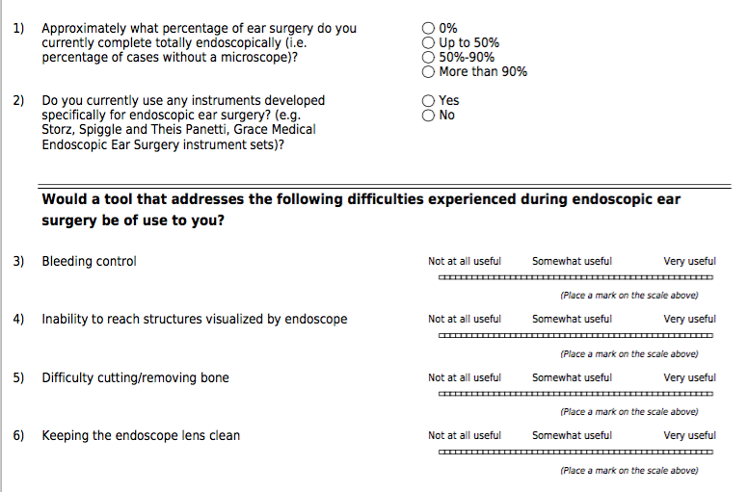

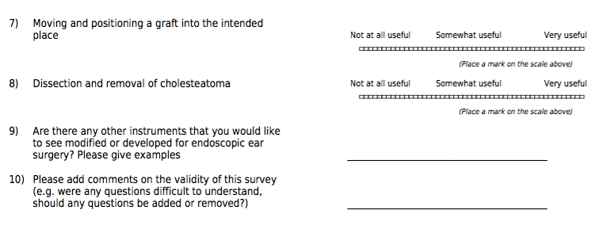

Appendix D: Timeline & Dissemination Plan

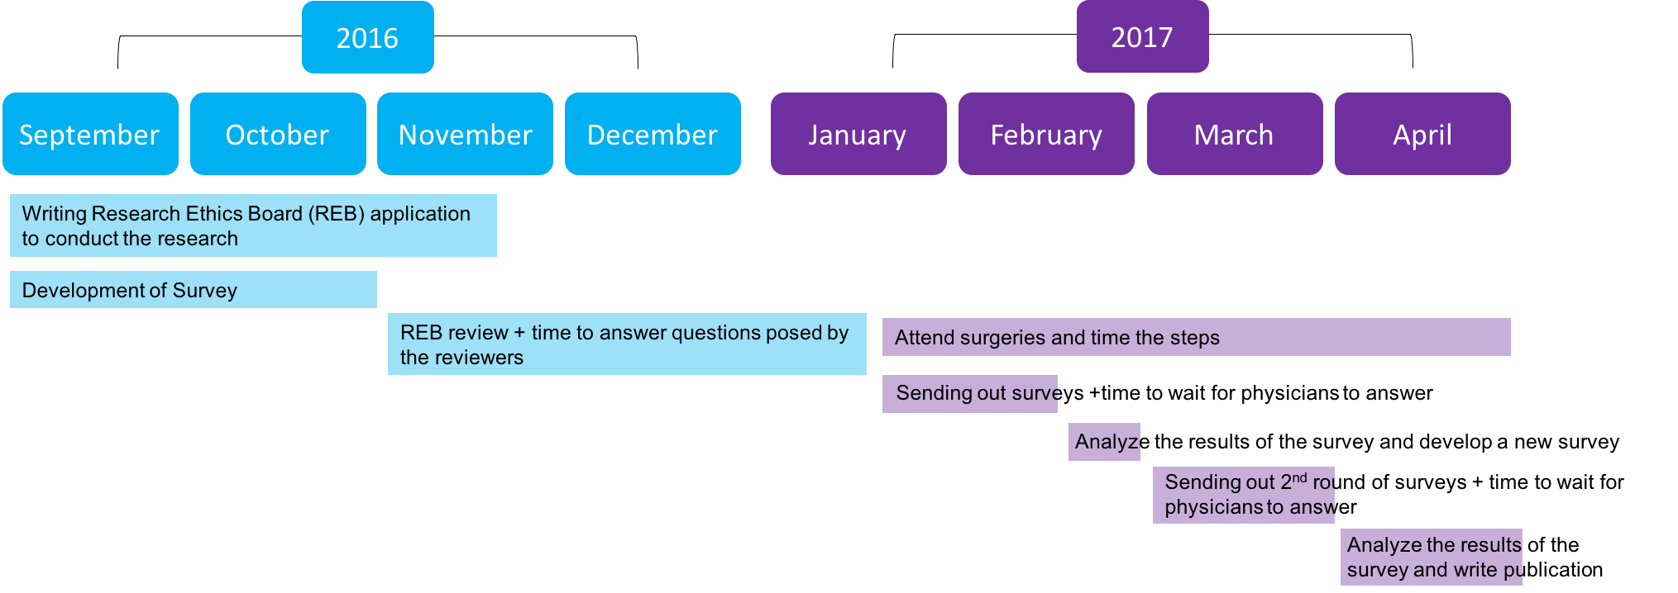

Boxes show approximate length of time required to complete the tasks.

The needs assessment and time flow study results will be submitted to the 2nd World Congress on Endoscopic Ear Surgery by the International Working Group of Endoscopic Ear Surgery (IWGEES). http://www.sinuscentro.com.br/iwgees/index.htm

**Itemized Review of Feedback:**

Reviewer Name: Kevin Ai Xin Jue Luo Investigator Name: Arushi Swarup Peer Review Committee #: 9 Project Title: Needs Analysis and Time Flow Study to Assess Endoscopic Ear Surgery Description of Project:

This project will focus on investigating the difficulties of implementing transcanal endoscopic ear surgery (TEES). Surveys, interviews, and time flow studies will be carried out to investigate why TEES is not being widely adopted even though it yields better results. A detailed step-by-step process is outlined, the result of which will potentially generate potential areas of improvement to the surgical method and tool designs.

1. Objective/research questions are clear. There are clearly two methods of approach to investigating the research questions. This is a very good question to ask.
2. The literature review section of the proposal is missing, however there are enough references and information presented to show that sufficient research has been done to back up the research direction.

A.S.: The literature review section has been added to follow the formatting of the proposal. The proposal initially had aims and methods integrated with literature review so the flow was better.

1. The rationale is very sufficient for the study, this study can lead to pushes for new technology being developed to improve surgical processes.
2. This research as potential to be innovative, and no research of this kind has been performed before.
3. The methods are very appropriate for achieving this objective, and the feasibility as well as the relevance of the proposed methods has been demonstrated.
4. The expected outcomes are very logical and complete. However some new information is presented, which may confuse readers.
5. The study is definitely feasible, since members of the surgeon community have already expressed their willingness to participate.
6. The organization of the Specific Aims and Methods Section was a little hard to follow. I think it would help if the sections under Part 1 and Part 2 were divided more consistently. Furthermore, I did not find an Appendix B.

A.S.: Appropriate appendices were added.

1. The document was very easy to read.
2. The ideas included in the proposal are solid, they just need a little bit more organization.

I’m curious to see the Data Collection Form proposed. I’m not sure if there is a standard way of  performing time flow studies, but I think taking reference from time studies used in the manufacturing might help. Just a suggestion

A.S.: The data collection form is included and is standard for collecting data for research purposes. Since publications include the results and analyses of studies, I have yet to come across a data collection form used to acquire data. Rather, the form will ensure that the appropriate information (duration of steps during surgery) is recorded – it does not matter in what format it is recorded as long as the appropriate information is recorded and analyzed in an appropriate format, eg. using statistical analysis practices.

**Review of Thesis Proposal (#1)**

Reviewer Name: Rami Saab Investigator Name: Arushri Swarup Peer Review Committee #: 9 Project Title: Needs Analysis and Time Flow Study to Assess Endoscopic Ear Surgery

*Brief description of project (to be completed by reviewer):*

A technique known as transcanal endoscopic ear surgery (TEES) can be used to perform minimally invasive surgeries of the middle ear through the ear canal. At present, the technique is difficult to administer and requires the surgeon to hold an endoscope with one hand while performing the procedure with the other. Existing tools are designed for two-handed operation and thus not suited for this application. As such, there has been poor adoption of TEES among otologists. This project proposes a study of the reasons for this low adoption rate. By using a time-flow analysis to analyze where instrumentation redesign is required along with a two-part Delphia survey sent out to members of ontology societies around the world, the study will provide insights into the basis for poor TEES adoption. Survey results will be analyzed using an ANOVA. The results of the study will help guide the design of better surgical instrumentation and the generated knowledge will be applicable to other minimally invasive natural orifice surgical techniques.

*1. Are the objectives/research questions clear?*

Your research question and associated objectives are clear and concise. The research objectives are separated into the two logical components: namely the survey questionnaire and the time-flow analysis. Also, I appreciate that you have followed my previous comments on the thesis proposal outline and have now added a question mark to the research question.

*2. Is the outline of the literature review appropriate and complete?*

You have adequate and proper academic references throughout your report. Further, your introduction does provide a good overview of the field. However, you have not explicitly included a Literature Review or Background section in your report. In my opinion I judge this to be acceptable as the nature of your project does not require an extensive review of literature. However, I only raise this concern because the rubric for marking does include this section. As such, I do not want you to lose marks just because your project doesn’t follow the prescribed form. I would encourage you to either contact the teaching assistant to inquire about this, or simply rearrange your proposal to include such a section.

A.S.: This has now been included.

I appreciate that you have justified the use of a two-step Delphi survey in your abstract (“The two-round Delphi method will conclude this in a rigorous format, as it is an accepted survey technique in many other areas of surgery”), however, I wonder if this is the best place to include this? You might be better off including this note either in your Introduction or perhaps in your newly made Background section and including a reference to applicable prior research.

A.S.: it has now been included in the literature review section.

*3. Is the rationale for the study coherent and complete?*

The rationale for the study is clearly described and is easy to understand. I appreciate that you have addressed my suggestion in the Thesis Proposal Outline review and now included a sentence exploring some of the advantages of using an endoscopic ear surgery over traditional surgeries.

*4. Is the research innovative?*

The research is important and innovative. It will pave the way to the development of a novel surgical tool for endoscopic ear surgeries and is an important first-step in the design process.

5. Are the methods (design, measurement, analysis) appropriate to achieve the objectives? The time flow analysis and survey methods are clearly explained. You have done a

great job stating the statistical tests you will be using to analyze the data. As a point of suggestion though, you make reference to an Appendix B but I couldn’t find this item within your appendix. I would suggest adding in the noted Data Collection Form or removing this reference from your text altogether. Furthermore, I would encourage you, if possible, to include some sample questions from the survey so that the reader can get a better idea of the form of the survey. For instance, will all the questions be open ended? Or will you ask for scale based responses? Also, how will you come up with the survey questions?

A.S.: This has now been addressed in the survey method explanation and in the appendices.

*6. Are the expected study outcomes compelling and complete?*

The expected outcomes of the study are compelling and complete. I have noticed that you have anticipated some survey results. This may not be a good idea as it indicates some bias in your expected outcomes. Also, you mention that you anticipate a low response rate for the offer of suggestions survey. I would encourage you to think about how you can develop, or rather, position, this part of the survey such that you will receive a greater number of responses.

A.S.: This has now been re-worded to provide better context.

*7. Is the study feasible?*

The study seems completely feasible. I have no reservations in this regard.

8. Is the organization of ideas clear and easy to follow? Following the standard thesis proposal outline, the research proposal is both clear and easy to follow. Sections have been clearly separated using appropriate headers and subsections are clearly outlined.

9. Was the document easy to read and understand? The document is very easy to read and understand. I have commented and outlined a few grammatical considerations but these are very minor. I believe some of these changes will enhance the readability of some sentences but you can choose to accept or reject these changes as you see fit.

A.S.: I have accepted these changes.

10. What is your overall assessment of the project? My overall assessment of the project is very positive. The proposal is very well written and it is evident that the project has been well thought out and is well positioned to be successful.

11. Please identify major issues and specific recommendations. I have no major issues with this Thesis Proposal. Overall, I thought it was very well done. I have documented a number of points above as well as in the text of the proposal itself that I would suggest you consider when developing your final proposal. However, these are largely minor considerations.

One thing I will say: I noticed that in your Expected Outcomes you explicitly identify some of the anticipated results from your survey. I am not sure that this is appropriate in this section. I am by no means an expert in how best to conduct a survey but I wonder if identifying these very specific results in your Expected Outcomes may cause you to, either consciously or not, bias some of the survey questions. Once again, this may not be the case depending on the nature of the questions you are asking (i.e. scale based responses versus open questions), nonetheless, it is something to think about. Perhaps, simply stating that the survey results will provide insights into the difficulties experienced by otologists during endoscopic ear surgery is sufficient as an expected outcome.

A.S.: The survey questions were developed based on discussions with surgeons, where I asked them open-ended questions about how they perceive TEES. These open-ended questions was my attempt to limit the bias and develop specific questions based on their feedback. This has now been added to the methods section.

In your Significance and Conclusions section you don’t mention how the results of this project will lead to the development of a novel surgical tool. I believe this is the logical next step following the successful completion of this portion of your research. Thus, I think you should state this clearly.

A.S.: done.

Also, you use square brackets for your citations in your Significance and Conclusion section while using round brackets everywhere else. You should make sure to stick to a consistent citation style.

A.S.: fixed that.